CS5231 System Security Homework 1

Lee Kai Wen, Aloysius (A0154597N)

# Code

#include <linux/sched/signal.h>

static int __init helloworld_lkm_init(void) {

size_t processes;

struct task_struct* task_list;

time64_t seconds;

printk(KERN_INFO "Hello, CS5231 Student!\n");

// Print number of processes running in the system

processes = 0;

for_each_process(task_list) {

processes++;

}

printk(KERN_INFO "Number of process: %zu\n", processes);

// Print current time in seconds since epoch

seconds = ktime_get_real_seconds();

printk(KERN_INFO "Current time: %llu\n", seconds);

return 0;

}

# Screenshot

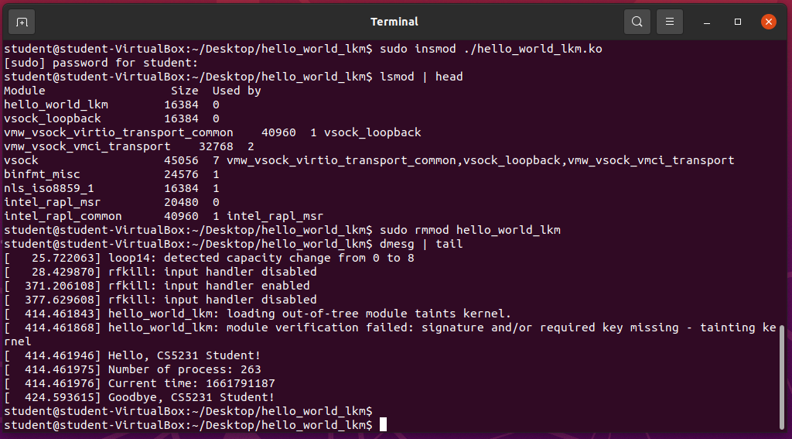

# References

Elixir Bootlin - Definition for for_all_process: <https://elixir.bootlin.com/linux/latest/source/include/linux/sched/signal.h#L645>

Elixir Bootlin - Example usage of for_all_process: <https://elixir.bootlin.com/linux/latest/source/arch/um/kernel/reboot.c#L25>

Linux Kernel documentation – ktime accessors:  
<https://docs.kernel.org/core-api/timekeeping.html#c.ktime_get_real_seconds>